**Qualitative Assignment: Creating a Video Game for HPV Education**

Chelsea L. Gould (Lacagnina)

Department of Public Health, Mercer University

MPH 675: Community Health Needs Assessment

Dr. August

December 1, 2021

**Qualitative Assignment: Creating a Video Game for HPV Education**

The general topics of research that the interview sought to answer include those on games, game consoles, enjoyment in games, character customization in games, HPV, HPV vaccine, and health education. These topics can be seen throughout the interview from the questions related to HPV and games.

**Purpose of the Interview**

The purpose of this interview was to understand what aspects of gaming people like to try to add these aspects to a game that will educate people on health. This is understood from the interviewer’s statement saying, “Games for health is this new field that is coming up in health education and a lot of researchers including myself are working on how we use games and video games and whether a game on a console, PC or mobile game, to kind of improve or to push people towards adapting a healthier lifestyle.” This statement also reveals the researchers plan on how the data collected will be used. The researchers seem to plan on using the collected data to understand whether a game would work to educate individuals on HPV. They will use the answers on what consoles are used most to know what format for a game would best work. The information on character customization and what individuals enjoy in a game will go into what would be included in the game to obtain players.

**Assessing the Interview**

This interviewer asked many relevant questions to understand what would be best to include in a game that educates individuals on HPV and how to go about doing this. The participants shared that this kind of information would either need to be embedded as a part of a story already in a popular video game or as a game that is used in schools as an alternative to lectures. Suggestions were received from participants on how to embed this knowledge into games. The interviewer also asked the participants about what they thought the benefits and challenges would be for an HPV video game.

**Interview Questions**

All these topics for the conversation led to crucial information on how to go about creating this type of education formatted into a game. I believe that the interviewer could have asked a few more questions to capture even more information that could be used to plan out this game creation. The interviewer discussed character customization with the participants but did not ask specifically, ‘How could we make a game like this more personally immersive?”. Some individuals said that they enjoy making a character that they see themselves in and some enjoy making a character that is unlike themselves, so I believe this is an important question. Many participants brought up the need to make this game online so that the character customization is more to show others, but they did not delve into the question of having a competitive or a collaborative game. If this is a game that could be played online with others, then it would be played either in a competitive or collaborative manner. If the game is being played with others, then the topic of anonymity should also be addressed. This is especially important if HPV is more prevalent in the game as this is a sensitive topic. Lastly, at the end of the interview the interviewer asked about creating a sexual profile in the game. I think this is an important question on whether this would be uncomfortable for people and make them not want to play the game. The transcript ended without this question really being answered.

**Strengths and Weaknesses of Interviewer**

The interviewer engaged in a light manner with the participants which was needed when talking about a sensitive subject, such as HPV. The interviewer also did well in summarizing what was talked about at multiple different points throughout the interview. After summarizing the interviewer asked if there was anything else to add which was a positive way of opening the conversation again for people to give more information and/or correct them in the summary. Though there were strengths for the interviewer there were also some weaknesses. The interviewer could have improved upon the formatting of their questions. The interviewer started out the session with a closed question that addresses the group answer and not the individual answers. They then did well to open the questions and had each participant answer but many times they asked multiple questions within one period of time, such as what they know and do not know about HPV. This can be a disadvantage as then participants may not answer all the questions.

**Analysis and Discussion**

**Themes**

The most discussed themes that emerged as part of the analysis included game characteristics, HPV virus and vaccine knowledge, health related game, gaming platforms, and character customization. Evidence of each theme can be seen from quotes that are related to the themes/subthemes (see Table 1). These themes showed up in the codes and then in the word clouds that were created to analyze the information.

Table 1

*Quotes that Support the Themes from the Interview*

| **Theme** | **Subtheme** | **Evidence #1** | **Evidence #2** | **Evidence #3** |
| --- | --- | --- | --- | --- |
| Game Character-istics | Freedom and Creativity | “Um, theres just little bit more creative freedom and even with like first person shooters, the ones that like have the most customizability like with the characters are the ones that I find to be most appealing.” | “The freedom of getting to like choose, especially like the good ones where like uh allow you to kind of pick different routes so you aren’t going to play the same game over and over again.” | “Um and the role playing games, um yeah just that creative freedom and not being tied down to play a game in one specific way.” |
|  | Time | “If I were to be playing video games, just because I don’t have a lot of time, it would have to be something where I could just rapidly ascend from one level to the next.” | “So if for example if I was studying or something I would take a little break and finish a quick race and after that move on.” | “Um, I’d say what attracts me to the first person shooters is that its, usually the graphics are really vivid, which is pretty cool, its almost like real life. Um, it, a lot of times has easy breaking points, so you can play for 20 minutes when you have time and stop at your check point and then kind off move on and so something else if that’s what you want to do.” |
| HPV Knowled-ge | Virus | “Um, I know that, or I think I know, um that its, probably a bigger issue in women than like what it can do, at least that’s what I’ve perceived. I think that from what I’ve heard, I don’t really feel that susceptible to it.” | “I really don’t have any knowledge on the virus.” | “I don’t know much about it. I actually didn’t even know men could get it till last week so, yeah. It’s never been brought up as an issue to me, um by my doctor, my parents, anyone.” |
|  | Vaccine | “Um I think before hearing your defense, I didn’t really know what there was like oh get a vaccination for HPV. That was like totally new and different for me, like I didn’t even know that was a thing really, yeah.” | “Um and I think it was only recommended for guys. If we even talked about, we offered it to guys if they wanted, with all of us not really knowing what was going on.” | “Um, I don’t know, its not really in my case, but its possible that a preconceived notion that may have is that by women getting the vaccination it kind of covers them too.” |
| Health Related Game |  | “I think the information we present and the game would have to be very accurate and very self-explanatory, you know if I’m playing a game and this pop up and I don’t really get it, then therefore this information that I might not gain from it may be barrier for me getting that knowledge.” | “I also think that the message should be brief short, just long enough to keep their attention, you know if you’re browsing reddit and you come across something doesn’t catch me, I’m going to keep going, I don’t care what it says.” | “I think that’s the benefit, you kind of remove some of the awkwardness and have that explicitly have that conversation.” |
| Gaming Platforms | Computer, Mobile Device, and Console Device | “Yes I bought a laptop. Predominantly for gaming and its even more great in terms of creative freedom as in computer games you can use MODs, yeah.” | “I do play a couple of games on my phone, I mean I have kind of deviated from that due to lack of time and I’ve invested more money in my console games.” | “Yeah I would say that a computer game would be a good middle ground for console gamers and the mobile app gamers, but only if it was like a more simple game.” |
| Character Customiz-ation | Physical Appearance and Skill Abilities | “For me it doesn’t but as long as its male that’s pretty much all I look for.” | “Like in the physical characteristics of my character, no they don’t matter at all, but depending on whether skills make a difference, then yeah skill customization would be.” | “And it really depends on the context on which you are playing in, like because if you are playing offline solo play, my customization really doesn’t matter to me, but if I was playing online like Halo or like first person shooter you know like where you get armor and stuff that shows that I’m a bad ass, I’m going to wear the badass armor but that’s like where the customization changes that it shows more of like my prestige versus just.” |

**Results**

To start analyzing the data, from within the script, a chart was made that shows the number of coding references that have been coded to a specific theme (see figure 1). This figure reveals that the most coding references were coded to ‘Additional Features and Characteristics to consider for HPV Vaccine Game’. The participants in the interview referenced approximately 24 features and characteristics that the researchers should consider when creating the HPV Vaccine Game.

Word frequency was then used to help identify key words in the text. Word clouds were created to visualize these keywords based on specific criteria. A word cloud was created based on the words in the entire script with removing the filler words from the cloud (see figure 2.1). This word cloud reveals the most talked about aspects of the interview. The key words that were discussed included “vaccine”, “knowledge”, “laughing”, “health”, “men”, and “console”. To visualize the platforms that were most talked about in the interview a word cloud was created identifying the platforms that were most used (see figure 2.2). A third word cloud was created to understand the overall sentiments towards what should be included in a game for health and how individuals feel about playing a game for health (see figure 2.3). The type of platform that the game is made for, having health education be embedded into an existing game, and bringing awareness to health education were all identified.

Using the text search function for a more in-depth look at specific words from the interview, multiple word trees were made (see figures 3.1-3.5). The word tree looked at “customize” and “customizing” (figure 3.1 and figure 3.11) to make the characters in the game more personal based on appearance and skill. Participants discussed that appearance does not usually matter unless you are playing with other people and want to show off your look. The word tree on “health” (figure 3.2) looked at the knowledge of health and prevention of health issues as well as having health be a component of a game and/or used as a curriculum learning tool to educate students. Figure 3.3 displays the discussion on the knowledge of the HPV virus and vaccine, how knowledge increases awareness, and how knowledge can be added into a health-related game. The “vaccine” word tree (figure 3.4) shows the knowledge of the participants on the HPV vaccine and the preconceived notions of the vaccine. Lastly, figure 3.5 touches on the knowledge of the participants on the HPV virus and the preconceived notions of the virus.

**Implications**

The results obtained can be used when creating a game, or a piece of content within an existing game, that will educate college men on the HPV virus and vaccine. The interview participants provided the researchers with information that can be used to create this game/content that will improve the knowledge and awareness of HPV for college men. They spoke on the platforms that are most used, the type of characters that are played, what education pieces would make them not want to play a health-related game, etc. The information from this will support the success of the game when it is being adopted into curriculum and/or household games. This improvement in the field of public health could reduce the number of individuals with the HPV virus in the future.

**Quality of the Data**

I am mostly satisfied with the quality of the data. I feel as though there is a large amount of data that can be analyzed to understand how to create a game, or content for a game, that includes a health-related piece. I do feel as though there are a few questions that are missing or should have been explored further. The interviewer asked the participants about anonymity but also about if they like playing games with others online. I believe these questions should have been expanded upon to better understand what parts of a health-related game they would want to play with friends and what parts they would want to play solo to have privacy/anonymity. It would be helpful to know what the participants thought about having a full solo game around health or if that would not be played as much as something with a bit of interaction. I also think that a game around HPV would touch on sexuality and sexual encounters. This was briefly asked at the end of the transcript when talking about a sexual profile, but no responses were recorded. Overall, I think the interviewer gained a lot of pertinent information but could formulate even more questions to fill in the gaps for the next round of interviews.

**Experience of Analyzing the Data**

Analyzing the data through NVivo was very difficult for me. I read articles online and watched some of the YouTube videos, but I was not sure I was coding correctly. I learned how to create codes and add sentences to the code that were relevant. I also learned how to create word clouds and word trees based off criteria that are set from the script or from a specific code. In the future, I could learn more about how to analyze in a more in-depth manner. I could learn to organize the script in NVivo by grouping the answers from each participant to the question asked. I would also like to learn to find and add more detailed codes and subcodes. During the analysis process, I would like to learn to use the mind map/concept map as it could provide a more understandable form of the results.

**Appendix**

Figure 1

*Count of Coding References*

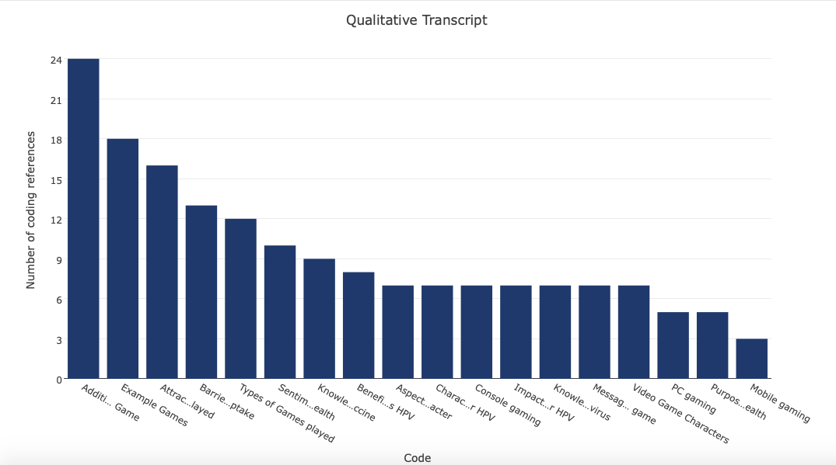

Figure 2.1

*Word Frequency in the Script (excluding filler words)*

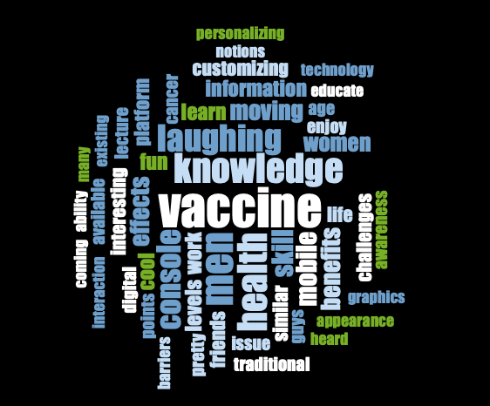

Figure 2.2

*Word Frequency of Gaming Platforms Discussed*



Figure 2.3

*Word Frequency of Sentiments about a Game for Health Education*

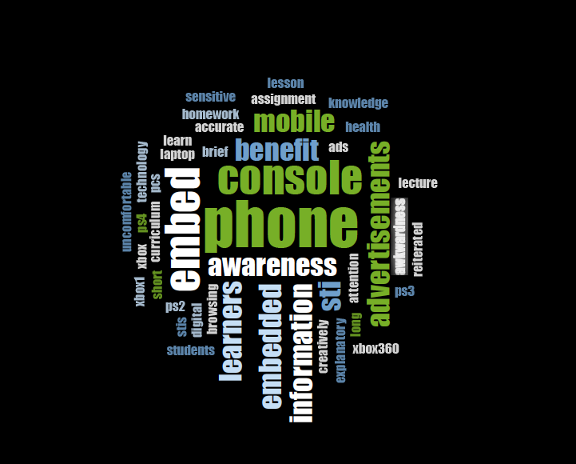

Figure 3.1

*Word Tree for “Customize”*

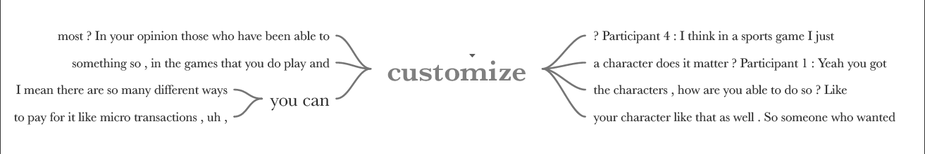

Figure 3.11

*Word Tree for “Customizing”*

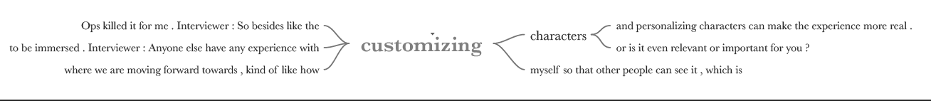

Figure 3.2

*Word Tree for “Health”*

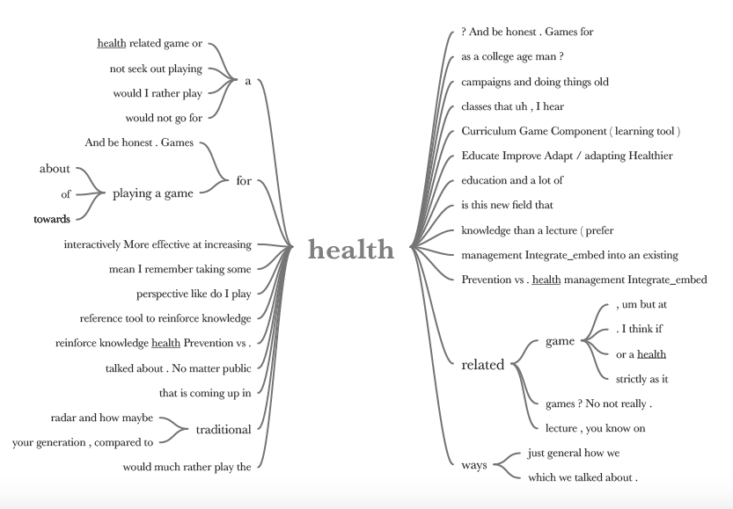

Figure 3.3

*Word Tree for “Knowledge”*

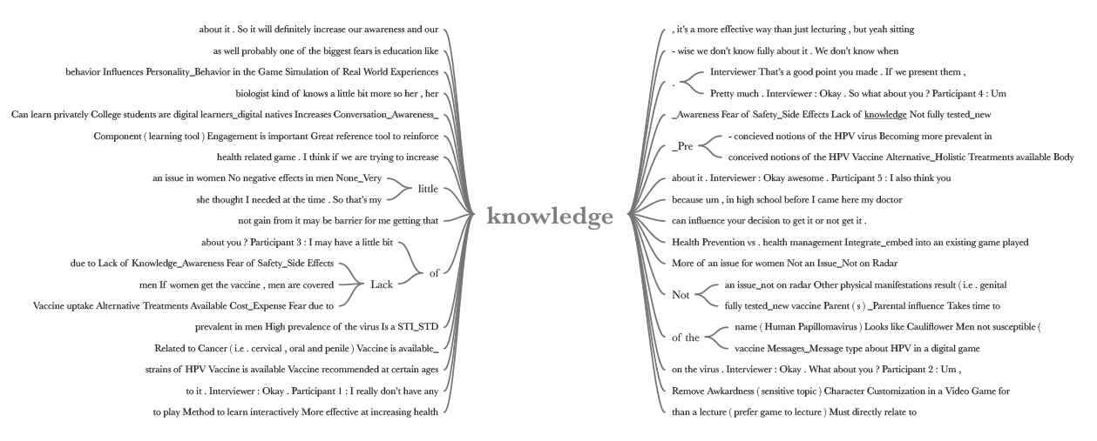

Figure 3.4

*Word Tree for “Vaccine”*

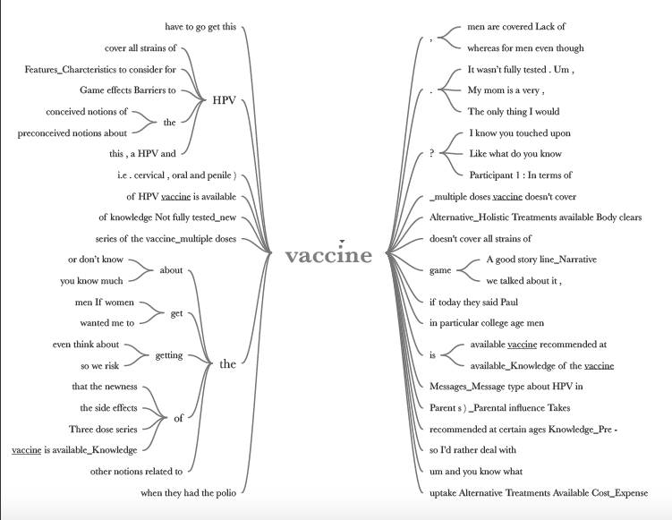

Figure 3.5

*Word Tree for “Virus”*

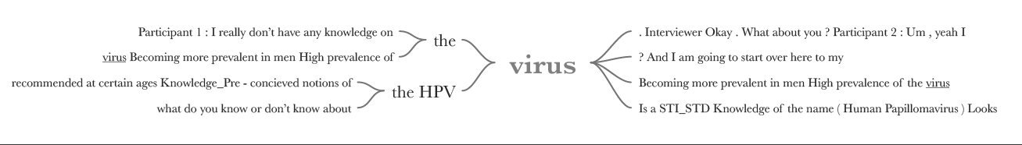

Table 2

*Final Codebook*

| **Name** | **Description** | **Files** | **References** |
| --- | --- | --- | --- |
| Additional Features_Charcteristics to consider for HPV Vaccine Game | Features and Characteristics that can help gain interest in individuals to play an HPV vaccine game. | 1 | 24 |
| Aspects most liked about video game character | Aspects of video game characters that are already in play that participants enjoy. | 1 | 7 |
| Attractive Characteristics_Features of the Video Games played | Aspects about video games in general that participants enjoy and would want to see in other games that they would play. | 1 | 16 |
| Barriers to HPV Vaccine uptake | Challenges to gaining participants to play a game that includes HPV vaccine education/knowledge. | 1 | 13 |
| Benefits of using a Digital Game to Discuss HPV | Advantages of using video game platforms to discussing HPV and HPV vaccines. | 1 | 8 |
| Character Customization in a Video Game for HPV | Whether or not character customization in a video game for HPV is necessary and what specific areas of customization would want to be seen. | 1 | 7 |
| Impact of Character Customization in Video Game for HPV | Specific positive and negative impacts the option of character customization can have on the experience of playing the game. | 1 | 7 |
| Knowledge_Pre conceived notions of the HPV Vaccine | What participants know and don’t know already about the HPV vaccine. This will help understand what gaps there are in knowledge that would be most useful to be taught in the game. | 1 | 9 |
| Knowledge_Pre-concieved notions of the HPV virus | What participants know and don’t know already about the HPV virus. This will help understand what gaps there are in knowledge that would be most useful to be taught in the game. | 1 | 7 |
| Messages_Message type about HPV in a digital game | They types of ways that the education on HPV virus and vaccine could be delivered through a video game platform. | 1 | 7 |
| Platform used to play video games | Types of platforms used for video gaming including what consoles are used. | 0 | 0 |
| Console gaming | Participants referencing console gaming. | 1 | 7 |
| Mobile gaming | Participants referencing mobile gaming. | 1 | 3 |
| PC gaming | Participants referencing computer gaming. | 1 | 5 |
| Purpose of Playing a Game for Health | Statements that lead to the purpose of why a health education game would be useful for HPV virus and vaccine information. | 1 | 5 |
| Sentiments towards playing a Game for Health | How participants feel about playing a game on health education for HPV virus and vaccine. | 1 | 10 |
| Video Game Characters | Characters from video games that were prominent in conversation brought up by participants. | 1 | 7 |
| Video Games played | Types of video games most played and examples of games that are played on consoles in today’s society. | 0 | 0 |
| Example Games | Specific games that participants stated they have played in the past. | 1 | 18 |
| Types of Games played | Ex: action, adventure, etc. | 1 | 12 |

*\*\*Re-organized “Examples of Video Games played” and “Type of Video Games played” into “Video Games Played” and subcodes of “Example Games” and “Types of Games played”.*

*\*\*Added “Purpose of Playing a Game for Health”.*